Start of game (Also Home)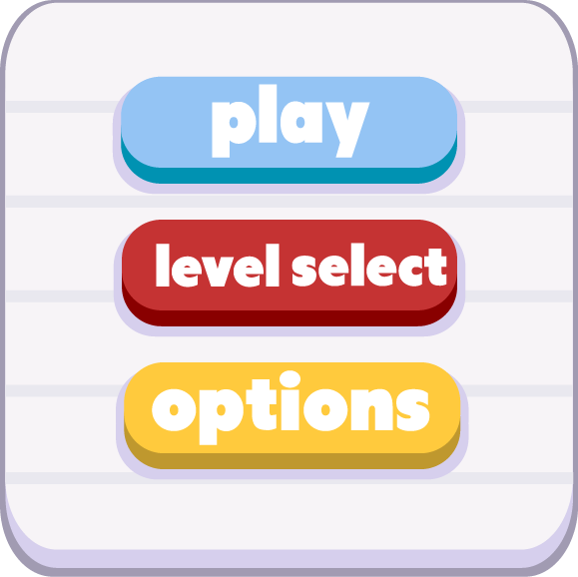

Game paused: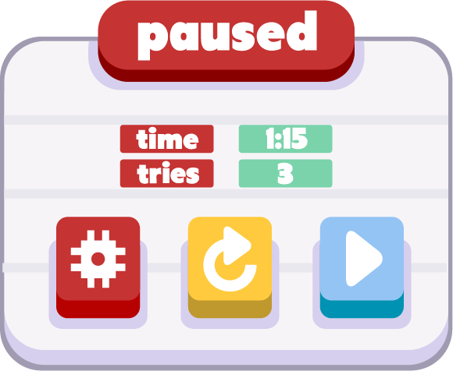

Level Select: (can replay previous levels but future levels are locked until player completes current stage)

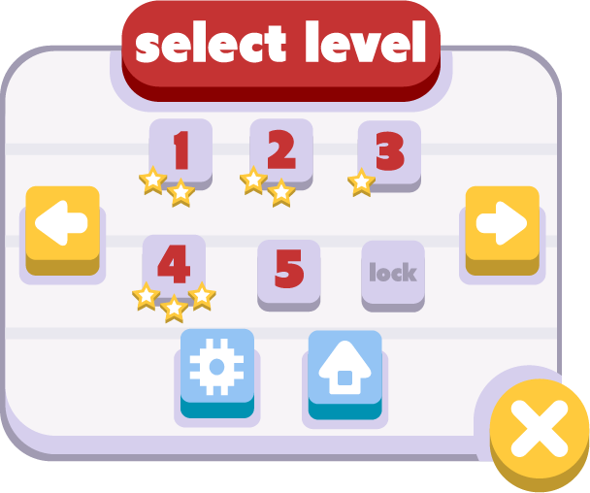

Brings to main screen

(rest of the stages in folder)

(different amount of stars -> different folder)

Stage Portal: 

Locked stage icon:

Pause Button (In Game) 

Control Button:(rest in folder)